Under Budget Database Design

Cameron Rutledge

Overview

Under Budget will be using a SQLite database to persist the data of my web application. I chose this due to the relationships my tables will possess to allow for the easiest storage and identification of expense sheets. The easiest way to track what expenditures a user has in a specific month is through a relational database.

Table Design

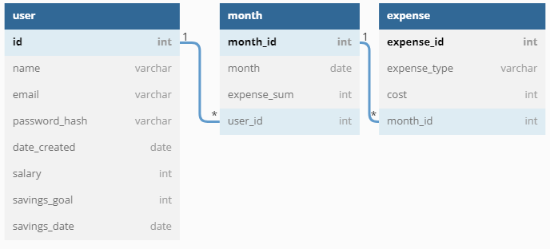

Users

My user table is comprised of an id primary key for identification, a name field for user greetings, along with an email and password (password_hash) field for user authentication. These values are all needed for when a new user is initialized, along with the date created field which logs the day the account was created. After a user has created their account they are able to set their salary, the amount they want to save(savings_goal), and by what date they want to have it saved by(savings_date). This information will be used when tracking and comparing the current savings progress tracked on expense sheets.

Table user as U {

id int [pk, increment]

name varchar

email varchar

password_hash varchar

date_created timestamp

salary int

savings_goal int

savings_date date

}

Month

My month table consists of an id primary key for identification, a month date field for tracking/displaying the chosen month/year, and a foreign key connection to my user table. There is a one to many relationship between the users and months table since a single user can track their expenses and generate multiple sheets over multiple months.

Stretch:

Implement tracking for an expense_sum value to assist with the stretch goal of tracking overall savings progress. This will be used to present overall savings since budgeting has started.

Table months as M {

month_id int [pk, increment]

month date

expense_sum int

user_id int

}

Ref: U.id < M.user_id

Expense

My expense table holds an id primary key for identification, an expense type (expense_type) field for the categorization of expenses, a cost field to store the expense, and a foreign key relationship between my months and expenses table as each month budget sheet will contain multiple expenses.

Table expenses as E {

expense_id int [pk, increment]

expense_type varchar

cost int

month_id int

}

Ref: M.month_id < E.month_id